

**PROGRAMMING CONTEST PROBLEM SET 2016**

**This problem set contains 8 problems (A-H).**

**2nd April 2016**



**Hosted by**

**Artificial Intelligence Society**

**Faculty of Computer and Mathematical Sciences**

**Universiti Teknologi MARA Shah Alam**

|  |  |  |
| --- | --- | --- |
| A | STRINGS TO THE GRAPH | |
| Input | Standard Input |
| Output | Standard Output |

**PROBLEM DESCRIPTIONS**

Abu teaches his son Zack to count every characters in each word, but Zack refuse to learn because he doesn’t like numbers. Since Abu knows that his son loves “Twinkle-twinkle little star” song, so he decided to change from count every characters to count every stars(asterisk). But what is the relation with the stars and characters? Nothing.

So here is the example :

“Twinkle twinkle little star”

The following graph will be plotted.

*******

*******

******

****

The number of rows equal to the number of words in the sentence.

**INPUT**

The first line contains the number of test cases. Each line on a test case contains a sentence of not more than 6 words. The sentence mush ends with a comma. The input only cover [a-zA-Z0-9] only.

**OUTPUT**

The graph for each dataset is printed separated with a blank line.

|  |  |
| --- | --- |
| Sample input | Sample output |
| 3  Twinkle twinkle little star ,  Hi my name is Zarul Izham ,  Artificial Intelligence Society , | *******  *******  ******  ****  **  **  ****  **  *****  *****  **********  ************  ****** |

|  |  |  |
| --- | --- | --- |
| B | BIG INTEGER | |
| Input | Standard Input |
| Output | Standard Output |

**PROBLEM DESCRIPTIONS**

Big Integer is one of Computer Science’s fields, where we’re dealing with a calculation that involving a very larger number than a computer can hold. By convention, size of integers that are available for general purpose computer is limited by size of processor registers.

Big integer is one of very important subject in computer science. One of application that are dealing with a very large number is in cryptography field. First practical public-key cryptosystem, RSA, is one of the example that’s involved with a very large prime number in order to generate resultant calculated integer which are hard to factories.

In this problem, you need to compute a sum of two numbers, let’s say *A* and *B.* You need to find a sum of *A + B = C*, where C is the answer that you need to calculate. Note that A and B can be a very large integer number.

**INPUT**

The first line of the input contains an integer T (1 ≤ T ≤ 5), the number of test cases. Following the first line are the test cases. Each test case contains two, where first is strings A, followed by string B after newline. Both A and B is strings with natural integer presentation [0, inf), such example is “0”, “123” and “999”. Length of string A, B is in range of 0 ≤ A, B ≤ 1000.

The input must be read from standard input.

**OUTPUT**

The output of the program should print the number resulted from sum of A and B followed by a new line for each answer.

The output must be written to standard output.

|  |  |
| --- | --- |
| Sample Input | Sample Output |
| 3  0  0  999  7775  999999999999999999999999999999999999  999999999999999999999999999999999999 | 0  8774  1999999999999999999999999999999999998 |

|  |  |  |
| --- | --- | --- |
| C | FACTORIAL OF A NUMBER | |
| Input | Standard Input |
| Output | Standard Output |

**PROBLEM DESCRIPTIONS**

In mathematics, the factorial of a non-negative integer *n* denoted by *n!*, is the product of all positive integers less than or equal to *n*. For example:

6! = 6 x 5 x 4 x 3 x 2 x 1 = 720

**Input**

The first line of the input contains an integer N (1 ≤N ≤ 5), the number of test cases. Following the first line are the test cases. Each line in a test case contains a non-negative integer number.

The input must be read from standard input.

**Output**

The output of the program should print the result of the factorial of the numbers.

The output must be written to standard output.

|  |  |
| --- | --- |
| **Sample Input** | **Sample Output** |
| 3  6  7  8 | 720  5040  40320 |

|  |  |  |
| --- | --- | --- |
| D | PALINDROME | |
| Input | Standard Input |
| Output | Standard Output |

**PROBLEM DESCRIPTIONS**

A positive integer is said to be a palindrome with respect to base b, if its representation in base b reads the same from left to right as from right to left. Palindromes are formed as follows:

Given a number, reverse its digits and add the resulting number to the original number. If the result isn't a palindrome, repeat the process. For example, start with 87 base 10. Applying this process, we obtain:

87 + 78 = 165

165 + 561 = 726

726 + 627 = 1353

1353 + 3531 = **4884**, a palindrome

Whether all numbers eventually become palindromes under this process is unproved, but all base 10 numbers less than 10,000 have been tested. Everyone becomes a palindrome in a relatively small number of steps (of the 900 3-digit numbers, 90 are palindromes to start with and 735 of the remainder take fewer than 5 reversals and additions to yield a palindrome). Except, that is, for 196. Although no proof exists that it will not produce a palindrome, this number has been carried through to produce a 2 million-digit number without producing a palindrome.

**Input**

The first line of the input contains an integer N (1 ≤ N ≤ 5), the number of test cases. Following the first line are the test cases. Each line of a test case contains an integer number. All test cases are non negative integer numbers.

The input must be read from standard input.

**Output**

Print the palindrome number produced and followed by for how many attempts the palindrome number is found. If no palindrome is produced after 10 attempts, print the last sum and the word “none”.

|  |  |
| --- | --- |
| **Sample Input** | **Sample Output** |
| 5  87  196  1689  46785  46894 | 4884;Palindrome;5  10755470;None  56265;Palindrome;5  1552551;Palindrome;4  664272356;None |

|  |  |  |
| --- | --- | --- |
| E | MAJLIS PRA GRADUAN | |
| Input | Standard Input |
| Output | Standard Output |

**PROBLEM DESCRIPTIONS**

Majlis Pra Graduan (MPG) is an event for final year student to celebrate their last semester before they go for Industrial Training. You have been assigned to lead this event by your club adviser, and need to select your own committee to help you organize this event.

There are many things that you need to consider and cover in order to make this event successful. You need to know how many students will attend this event, food to be reserved and other cost related to this event.

You propose your budget to your adviser to seek for his/her approval. Things that you need to include in your budget is :

* venue cost,
* food cost,
* transport cost and
* others cost like banner and doorgift.

But your budget automatically approve if the total cost are in the range given below, based on the number of student.

|  |  |
| --- | --- |
| Number of students | Total Cost Budget Approve |
| 1-20 | <= RM2000 |
| 21-50 | <= RM4000 |
| 50 < | <=RM10000 |

**Input**

The first line of the input contains an integer N (1 ≤ N ≤ 5), the number of test cases. Following the first line are the test cases. Each line of a test case contains your budget proposed which are number of student, venue cost, food cost, transport cost and other cost.

**Output**

Display the status whether approved or denied.

|  |  |
| --- | --- |
| **Sample Input** | **Sample Output** |
| 5  87 600 5500 174 300  20 200 1000 200 500  49 650 3000 220 400  1 100 10 1 1  43 2300 4403 4400 400 | APPROVED  APPROVED  DENIED  APPROVED  DENIED |

|  |  |  |
| --- | --- | --- |
| F | TOTAL & MEAN | |
| Input | Standard Input |
| Output | Standard Output |

**PROBLEM DESCRIPTIONS**

You are required to find the total and mean of data collected for 10 cities for this month. The

data contains the number of car thefts happened in the cities.

**Input**

The first line of the input contains an integer N (1 ≤ N ≤ 5), the number of test cases. Following the first line are the test cases. The line of input are 10 Integer numbers (1 ≤ N ≤ 500) which indicate the number of car theft happened in 10 cities.

**Output**

The output will show the total number of car thefts for all 10 cities and the mean score.

|  |  |
| --- | --- |
| Sample Input | Sample Output |
| 2  10 15 60 55 17 23 41 5 18 14  12 12 12 12 12 12 12 12 12 12 | 258 25  120 12 |

|  |  |  |
| --- | --- | --- |
| G | THE SQUARE MATRIC | |
| Input | Standard Input |
| Output | Standard Output |

**PROBLEM DESCRIPTIONS**

In mathematics, a square matrix is a matrix with a same number of rows and columns. An *n-by-n* matrix is known as a square matrix of order *n*. For instance, this is square matrix of order 3:

**

Write a program that is able to display a square matrix of any order as specified by the user. All the entries of the matrix are 1s except the entries in the main diagonal and anti-diagonal. The entries in both diagonals should be 0s.

**Input**

The first line of the input contains an integer N (1 ≤ N ≤ 5), the number of test cases. Following the first line are the test cases. The line input can be any integer number.

**Output**

The square matrix of any order as specified by the user with its entries in principal diagonal and anti-diagonal is 0s. The rest of the entries remain to be 1s.

|  |  |
| --- | --- |
| **Sample Input** | **Sample Output** |
| 2  7  4 | 0 1 1 1 1 1 0  1 0 1 1 1 0 1  1 1 0 1 0 1 1  1 1 1 0 1 1 1  1 1 0 1 0 1 1  1 0 1 1 1 0 1  0 1 1 1 1 1 0  0 1 1 0  1 0 0 1  1 0 0 1  0 1 1 0 |

|  |  |  |
| --- | --- | --- |
| H | Way Too Long Words | |
| Input | Standard Input |
| Output | Standard Output |

**PROBLEM DESCRIPTIONS**

Sometimes some words like "localization" or "internationalization" are so long that writing them many times in one text is quite tiresome.

Let's consider a word too long, if its length is strictly more than 10 characters. All too long words should be replaced with a special abbreviation.

This abbreviation is made like this: we write down the first and the last letter of a word and between them we write the number of letters between the first and the last letters. That number is in decimal system and doesn't contain any leading zeroes.

Thus, "localization" will be spelt as "l10n", and "internationalization» will be spelt as "i18n".

You are suggested to automatize the process of changing the words with abbreviations. At that all too long words should be replaced by the abbreviation and the words that are not too long should not undergo any changes.

**Input**

The first line contains an integer *n* (1 ≤ *n* ≤ 100). Each of the following *n* lines contains one word. All the words consist of lowercase Latin letters and possess the lengths of from 1 to 100 characters.

**Output**

Print *n* lines. The *i*-th line should contain the result of replacing of the *i*-th word from the input data.

|  |  |
| --- | --- |
| Input | Output |
| 4  word localization internationalization pneumonoultramicroscopicsilicovolcanoconiosis | word l10n i18n p43s |

P/S : SOME OF THE QUESTIONS CREDIT TO **C-PROM UITM PERLIS ORGANIZER**, **UITM PERLIS LECTURERS AND MY FRIENDS** BECAUSE I TOOK THE QUESTIONS DIRECT FROM THEIR PROBLEM SET.

**SCOREBOARD FINAL**

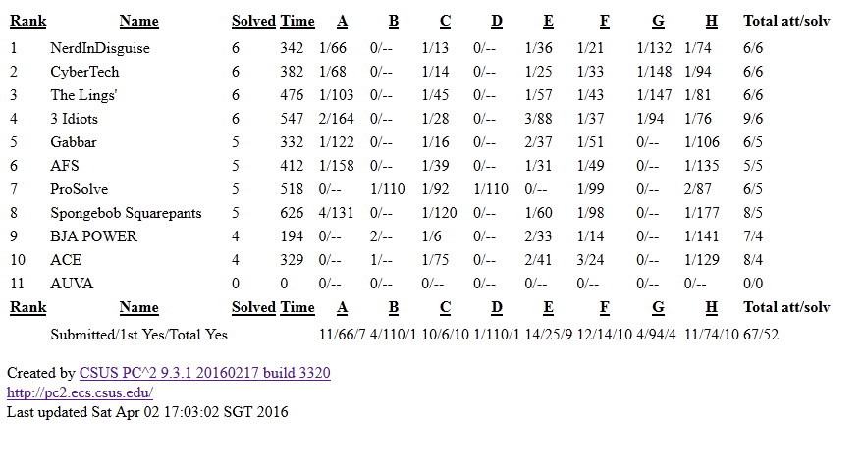

CONGRATS TO ALL!!